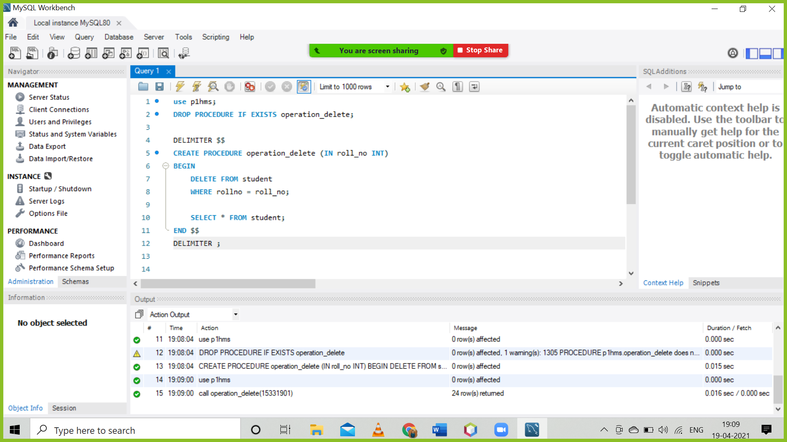

insert into teacher values(‘Kantilal’,’Popatlal’,’45’,’10-10-1976’,’ Prahladnagar, Ahmedabad’, ‘9898709876’, ‘Kantilal.p@gmail.com’, ‘89’, ‘91’, ‘456723406196’, ‘B.Tech’, ‘1019121’, ‘Computer Science’);

insert into teacher values(‘Vishnubhai’,’Babulal’,’50’,’20-02-1971’,’ Gota, Ahmedabad’, ‘7512309876’, ‘Vishnu.b@gmail.com’, ‘86’, ‘81’, ‘782345406196’, ‘B.Tech’, ‘1019122’, ‘Computer Science’);insert into teacher values(‘Subhramanyam’,’Divyanagar’,’43’,’30-07-1978’,’ Bangalore, Bangalore’, ‘7924513680’, ‘Subhramanyam.d@gmail.com’, ‘91’, ‘94’, ‘734234061961’, ‘B.Tech’, ‘1019123’, ‘Computer Science’);

insert into teacher values(‘Kashyapbhai’,’Ashvinkumar’,’45’,’12-03-1976’,’ Prahladnagar, Ahmedabad’, ‘8967309876’, ‘Kashyap.a@gmail.com’, ‘78’, ‘81’, ‘455623345696’, ‘B.Tech’, ‘1019124’, ‘Electrical’);

insert into teacher values(‘Sharadlal’,’Kantilal’,’55’,’15-05-1966’,’Thaltej, Ahmedabad’, ‘8923462829’, ‘Sharad.k@gmail.com’, ‘80’, ‘90’, ‘232315340696’, ‘B.Tech’, ‘1019125’, ‘Electrical’);

insert into teacher values(‘Ashokbhai’,’Chamanlal’,’60’,’12-12-1961’,’ prahladnagar, Ahmedabad’, ‘9892314876’, ‘Ashok.c@gmail.com’, ‘89’, ‘87’, ‘448893406196’, ‘B.Tech’, ‘1019126’, ‘Electrical’);

insert into teacher values(‘Mohammad’,’Aashirbhai’,’49’,’18-10-1980’,’ Nanpura,Surat’, ‘8989606876’, ‘Mohammad.a@gmail.com’, ‘79’, ‘81’, ‘112223406196’, ‘B.Tech’, ‘1019127’, ‘Civil’);

insert into teacher values(‘Shrikrishna’,’Divanagar’,’51’,’30-07-1970’,’ Mangalore, Mangalore’, ‘7989011780’, ‘Shrikrishna.d@gmail.com’, ‘91’, ‘94’, ‘546830061861’, ‘B.Tech’, ‘1019129’, ‘Civil’);

insert into teacher values(‘Sameerbhai’,’Shahirbhai’,’45’,’17-09-1976’,’ Undera , Vadodara’, ‘8798700786’, ‘Sameer.s@gmail.com’, ‘89’, ‘88’, ‘180021206196’, ‘B.Tech’, ‘1019130’, ‘Mechanical’);

insert into teacher values(‘krishna’,’Subhramanya’,’50’,’31-03-1971’,’Thirunavantapuram,Kerala’, ‘7001231780’, ‘krishna.s@gmail.com’, ‘81’, ‘84’, ‘500128061861’, ‘B.Tech’, ‘1019132’, ‘Mechanical’);

insert into teacher values(‘Rohitbhai’,’Krantibhai’,’45’,’19-11-1976’,’ Prahladnagar, Ahmedabad’, ‘9123409076’, ‘Rohit.k@gmail.com’, ‘85’, ‘92’, ‘456700126196’, ‘B.Tech’, ‘1019133’, ‘Electronics’);

insert into teacher values(‘Mohiniben’,’Prakashbhai’,’39’,’20-02-1982’,’ Memnagar, Ahmedabad’, ‘9002309876’, ‘Mohini.p@gmail.com’, ‘81’, ‘84’, ‘780045776106’, ‘B.Tech’, ‘1019134’, ‘Electronics’);

insert into teacher values(‘Shvetaben’,’Aakashbhai’,’43’,’30-07-1978’,’Mundra,Kutchh’, ‘7856513680’, ‘Shveta.a@gmail.com’, ‘87’, ‘88’, ‘810234011900’, ‘B.Tech’, ‘1019135’, ‘Electronics’);

insert into subject values('15336413', 'CSE250', 'CSE200', 'ENR204', 'MAT102', 'COM102');

insert into marks values('15336413', '68','91','64','83','71');

insert into subject values('15331970','CSE250','CSE200','ENR204','MAT102','COM102');

insert into marks values('15331970', '75','92','66','82','73');

insert into subject values('15339302','CSE250','CSE200','ENR204','MAT102','COM102');

insert into marks values('15339302', '73','94','62','86','72');

insert into subject values('15336884','CSE250','CSE200','ENR204','MAT102','COM102');

insert into marks values('15336884', '79','98','69','89','73');

insert into subject values('15335577','CSE250','CSE200','ENR204','MAT102','COM102');

insert into marks values('15335577', '77','96','65','84','72');

insert into subject values('15331902','CSE250','CSE200','ENR204','MAT102','COM102');

insert into marks values('15331902','75','91','67','82','70');

insert into subject values('15331903','CSE250','CSE200','ENR204','MAT102','COM102');

insert into marks values('15331903', '74','92','64','83','75');

insert into subject values('15331904','CSE250','CSE200','ENR204','MAT102','COM102');

insert into marks values('15331904', '78','93','65','84','79');

insert into subject values('15331905','CSE250','CSE200','ENR204','MAT102','COM102');

insert into marks values('15331905', '70','96','66','81','73');

insert into subject values('15331905','CSE250','CSE200','ENR204','MAT102','COM102');

insert into marks values('15331905', '72','97','62','82','74');

insert into subject values('15331906','CSE250','CSE200','ENR204','MAT102','COM102');

insert into marks values('15331906', '75','94','64','86','75');

insert into subject values('15331907','CSE250','CSE200','ENR204','MAT102','COM102');

insert into marks values('15331907', '73','98','65','88','76');

insert into subject values('15331908','CSE250','CSE200','ENR204','MAT102','COM102');

insert into marks values('15331908', '78','93','63','84','70');

insert into subject values('15331909','CSE250','CSE200','ENR204','MAT102','COM102');

insert into marks values('15331909', '79','99','68','89','77');

insert into subject values('15331910','CSE250','CSE200','ENR204','MAT102','COM102');

insert into marks values('15331910', '74','93','69','85','75');

insert into subject values('15331911','CSE250','CSE200','ENR204','MAT102','COM102');

insert into marks values('15331911', '77','95','66','84','79');

insert into subject values('15331912','CSE250','CSE200','ENR204','MAT102','COM102');

insert into marks values('15331912', '79','93','64','83','76');

insert into subject values('15331913','CSE250','CSE200','ENR204','MAT102','COM102');

insert into marks values('15331913', '71','97','63','87','74');

insert into subject values('15331914','CSE250','CSE200','ENR204','MAT102','COM102');

insert into marks values('15331914', '72','94','62','80','73');

insert into subject values('15331915','CSE250','CSE200','ENR204','MAT102','COM102');

insert into marks values('15331915', '70','95','64','88','72');

insert into subject values('15331917','CSE250','CSE200','ENR204','MAT102','COM102');

insert into marks values('15331917', '70','97','66','88','76');

insert into subject values('15331918','CSE250','CSE200','ENR204','MAT102','COM102');

insert into marks values('15331918', '75','92','63','86','77');

insert into subject values('15331919','CSE250','CSE200','ENR204','MAT102','COM102');

insert into marks values('15331919', '78','91','62','83','72');

insert into subject values('15331920','CSE250','CSE200','ENR204','MAT102','COM102');

insert into marks values('15331920', '76','92','64','81','71');